REGISTRATION NOW OPEN

A Quiet Walk with Jesus
OSL Region 2 Fall Retreat

Tuscarora Inn & Conference Center
Mount Bethel, PA
October 13-15, 2021

Carolyn Rae, Region 2 Director

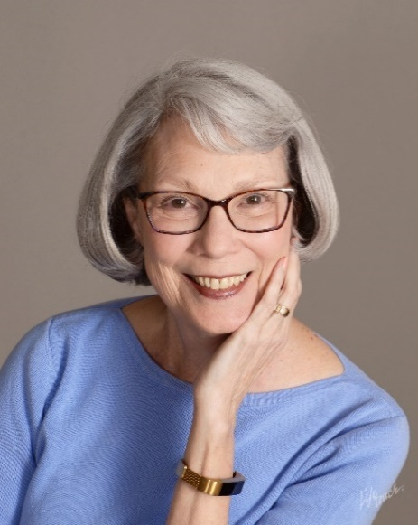
“Love is Healing”
Meditations on the
healing power of love.

- God’s Love for Us
- Our Love for God
- Our Love for Ourselves
- Our Love for Others

Bio –I experienced God’s presence early in life when He answered my fearful prayer with the His Peace & Love. Through the years I have grown ever closer to God as He has moved in my life in truly miraculous ways, healing and restoring me through His Love.

I first became involved in the Order of Saint Luke (OSL) in the early 1990’s when my husband, Paul, and I began attending the Chevy Chase Chapter (later to become the National Capital Chapter) of OSL. During our time in this community, I have offered workshops, led prayer groups and served as a Prayer Minister at OSL events. In 2012, Paul and I moved to Winchester, VA, where no OSL chapter existed. Following the 2014 Region 2 OSL Conference, we joined with other local OSL members and helped found a new community, the Shenandoah Region Healing Community of OSL. Our healing community has already been involved in healing services in the area. We have also held several Healing Conferences. In addition, we offer healing prayer at Health Fairs sponsored by Our Health in Winchester.

In 2016 I was elected and inducted as Director of Region 2 of OSL. During my time as Director of Region 2 I have led healing missions as well as speaking at healing services. In addition to my work with OSL, I have been in leadership in Bible Study Fellowship and lead my neighborhood Bible Study.

OSL Region 2 Annual
A Quiet Walk with Jesus
Oct 13-15, 2021
Tuscarora Inn & Conference Center, Mount Bethel, PA
Registration Form
Please complete this form and mail to arrive by Sept 15th with your payment made payable to….
Order of St Luke
And mail to…
Vivian Stein
1113 Cherry Street
Charlottesville, VA 22902

For more information or scholarship request, contact Carolyn Rae at 540-504-7260 or OSLRegion2Director@gmail.com

Name: Roommate:
Address:
Telephone: Email:

Conference Costs (total includes $40.00 non-refundable registration fee)
Riverside (Single: $360, Double $280)
Cottage (Single: $295, Double $230) | SOLD OUT
Donation for the David Sanderlin Scholarship Fund
Contribution to OSL Region 2
Total Included

Contact Vivian Stein at beancounterhelp@outlook.com or 434/760-6555 for the potential of housing refunds if needed. Room assignments will be on a first come first serve basis. We cannot guarantee housing above our reserved rooms, so sharing is suggested as well as getting your reservation in as early as possible

