Region 2 OSL Annual Conference

Shrine Mont Conference Center
Orkney Springs, VA
May 9-12, 2022

Rev. Nigel Mumford
Keynote Speaker

This is Where Your Healing Begins

- Foundations of Healing
- Challenges to Healing
- Emotions That Need Healing

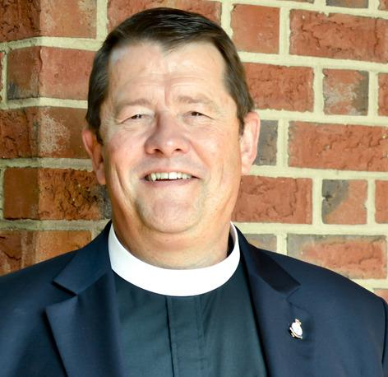
Nigel has been involved in the healing ministry since 1991. He has been the director and founder of two healing centers, The Oratory of the Little Way in Connecticut (1996-2004) and one in upstate New York. (2004-2013). Ordained in 2005, Fr. Nigel is an author, international speaker and founder of By His Wounds, Inc., a ministry, committed to restoring the healing gifts of Jesus Christ. Born & educated in England, he served in the Royal Marine Commandos for 7 years, and for the last two years was a Drill Instructor at the Commando Training Center. A great deal of his ministry is the Welcome Home Initiative, reaching out to all veterans suffering in from post-traumatic stress or moral injury. Nigel travels throughout the United States, Canada, England, and Sweden teaching on the Healing Ministry of Jesus Christ, and leading retreats for veterans who suffer in silence with Post Trauma Stress. Central to his ministry are the words of Jesus: Preach the Kingdom and heal the sick. (Luke 9:2)

Preconference Workshops

Please join us on May 9-10 for workshops on Blessings presented by OSL Region 2 member, Katie Lucas. These workshops will teach you how and when to use blessings in your prayer ministry. The workshops will include practicums on blessings which will enrich and enlarge your prayer ministry.
SCHEDULE
2022 REGION 2 ANNUAL MEEETING
Pre-Conference Workshops – May 9-10
Conference – May 10-12

Monday, May 9, 2022
2:00 p.m. | Registration
4:00 p.m. | Director’s Council Meeting
5:30 p.m. | Dinner
6:30 p.m. | Welcome – Carolyn Rae  First Workshop – What are Blessings and How to Get Them – Katie Lucas  Prayer Time
8:30 p.m. | Fellowship & Light Refreshments
Tuesday, May 10 ,2022
8:00 a.m. | Breakfast
9:00 a.m. | Second Workshop – Divine Purposes of Blessing – Katie Lucas  Prayer Time
11:00 a.m. | Third Workshop – How to Give Blessings – Katie Lucas  Prayer Time
12:30 p.m. | Lunch
2:00 p.m. | Free Time or Q&A Discussion with workshop presenter
2:00 p.m. | Registration
4:00 p.m. | Chaplains and Conveners Meeting
5:30 p.m. | Dinner
6:30 p.m. | Welcome – Carolyn Rae  Speaker, Nigel Mumford – Foundations of Healing  Healing Prayer
8:30 p.m. | Fellowship & Light Refreshments
Wednesday, May 11, 2022
8:00 a.m. | Breakfast
9:00 a.m. | Prayer Groups
10:30 a.m. | Holy Communion  Speaker – Nigel Mumford – Challenges to Healing
12:30 p.m. | Lunch
1:30 p.m. | Region 2 Annual Business Meeting with Inductions
2:30 p.m. | Prayer Groups
3:30 p.m. | Free Time
5:30 p.m. | Dinner
6:30 p.m. | Speaker – Nigel Mumford – Emotions That Need Healing  Healing Prayer
8:30 p.m. | Fellowship & Light Refreshments
Thursday, May 12, 2022
8:00 a.m. | Breakfast
9:00 a.m. | Burning of Prayer Requests
9:30 a.m. | Closing Service with sharing of blessings, commissioning of new Region 2 Director and Holy Communion
11:30 a.m. | Depart for home

REGISTRATION
REGION 2 ANNUAL CONFERENCE
SHRINE MONT CONFERENCE CENTER
ORKNEY SPRING, VA
MAY 9-12, 2022

Last Name:

First Name:

Address:

Phone:

Email:

Item: | Amount: | # Attendees: | Total:
Non-Refundable Registration Fee | $40.00
2 nights single room & board | $295.00
3 nights single room & board | $440.00
2 nights double room & board | $225.00
3 nights double room & board | $335.00
Donation for Sanderlin Scholarship Fund
Donation for OSL Region 2
Total Paid:

*Registration Fee is non-refundable.

Roommate for double room:

If you would like to attend but will not be staying at Shrine Mont, please call Vivian Stein at 434-760-6555 for costs.

To apply for a $100 scholarship, please call Vivian Stein at 434-760-6555.

Mail registration form to: Vivian Stein
1113 Cherry Street
Charlottesville, VA 22902

